# **Assessment 3 (Part D) - Self testing for web development project**

|  |  |  |  |  |  |
| --- | --- | --- | --- | --- | --- |
| **Student Name:** | **Kevin Le** | **Student ID:** | **S3945939** | **Jupiter URL:** | **https://jupiter.csit.rmit.edu.au/~s3945939/ProjectStage3/index.php** |

**Have the following functions been created?**

Display all records

Display more details about a record

Search for records

Insert a record

Update a record

Delete a record

## 

**Is your project on the RMIT file and database servers?**

* Website files have been uploaded to the RMIT file server (Jupiter)
* Image folder permissions are set to 777 (to allow image upload to occur)
* Database tables have been created on Jacob5 MySQL Server

**Instructions for testing**

* Read and complete each test
* Write a comment for each test
  + what happened when you ran the test?
  + does your project match requirements?
* Fix any errors or missing components

## Technical Specifications (client requirements)

|  |  |  |
| --- | --- | --- |
| **TOPIC** | **TEST** | **COMMENT** |
| **Main heading** | Does every web page have a main heading? | Yes |
| **Navigation** | Does every web page have a navigation?  Does the navigation have the required options - home page, inserting records, and modifying records? | Yes |
| **Home page** | Are 6 records displayed on the home page?  Is a name, image and hyperlink included for each record? | Yes |
| **Details page** | Is additional information about the topic displayed on the details page? | Yes |
| **Search** | Does every page have a search option? | Yes |
| **Appearance** | Do all web pages have a consistent appearance?  Examine the styles applied to   * Main heading * Navigation * Search * Background colour, fonts * Layout | Yes |
| **Images** | Are all images in an images folder?  Is the maximum size of all images 500px?  Do all images have meaningful names? | Yes |

## Retrieve and display records

|  |  |  |
| --- | --- | --- |
| **TOPIC** | **TEST** | **COMMENT** |
| **Navigation** | Test all navigation hyperlinks   * Do all navigation hyperlinks work? * Do they go to the correct pages? | Yes |
| **Display all records** | Select **Home** on the navigation   * Are the names of the events / places clearly displayed? * Are the images relevant to the event / place?   Click the **details hyperlink** for **each** event / place   * Is the correct record displayed? | Yes |
| **Display more details** | View the details for each record   * What additional information is displayed? * Is the text easy to read? * Is there adequate space between elements on the page? * Is there a navigation and main heading on this page? | * What additional information is displayed?   Description  Everything else, yes |
| **Search** | Which database fields / columns are used for the search? | Description and Name | |
| **Search results - valid data** | Search using keywords which exist in one or more records   * Are details of records matching the search criteria displayed? * Is navigation / search bar displayed? | Yes, screenshots shown below | |

|  |  |  |
| --- | --- | --- |
| **Search results - invalid data** | Search using keywords which are NOT in the database table   * Is a message displayed telling the user that no records were found? | Yes, screenshots shown below |

## Insert Records

|  |  |  |
| --- | --- | --- |
| **TOPIC** | **TEST** | **COMMENT** |
| **Form** | Click the navigation option for **inserting a record**  View the form   * Do the form fields match the required database fields (excluding auto generated fields)? | Yes |
| **Inserting a new record** | Enter data into all fields using a test record   * Is a confirmation message displayed?   Select Home option on the navigation   * Is the name and image of the new record displayed?   Click the details hyperlink   * Is the correct record displayed? | Yes, screenshots shown below |
| **Checking for empty fields** | Insert data for a new record BUT leave one text field blank and do not browse for an image   * Is a message displayed telling the user that fields cannot be left blank? * A new record should not be added if there are blank fields | Yes, screenshots shown below |
| **Cleansing form data** | Insert text with both single and double quotes and press submit  The record should be created with no errors.  Select the navigation option to **display all records** and view the new record  The text should contain the quotation marks | Yes, screenshots shown below |

## Update Records

|  |  |  |
| --- | --- | --- |
| **TOPIC** | **TEST** | **COMMENT** |
| **Update Form** | Select modify  Choose a record to update   * Is the data displayed in the form input areas? * What fields can be updated? | Data displayed in the form input areas are name, location, theme and description |
| **Update test 1 - text** | Make changes to the text data   * type in something obvious like aaaaa   Click update   * What message displays on the page? * Is there a navigation on the page?   Select the navigation option to display all records   * Has the record been updated with the new data? | Yes, screenshots shown below |

|  |  |  |
| --- | --- | --- |
| **Update test 2 - quotes** | Make changes to the text data   * Type text with both single and double quotes.   Click Update  View the result using the navigation option to display all records   * Check that the data displays with quotation marks | Yes, screenshots shown below |

## Delete Records

|  |  |  |
| --- | --- | --- |
| **Test 1**  Confirmation page and cancel | Select modify  Choose a record and click the delete hyperlink  View the confirmation page   * Are the record details clear? * Is there a clear delete confirmation heading? * Is there a cancel hyperlink?   Click the **cancel** hyperlink   * Are you returned to the previous page? | Yes, screenshots shown below |
| **Test 2**  Delete a database record and remove the image from the folder | Select a testing **record** to delete  View the confirmation page  Click the delete hyperlink   * What message is displayed? * Is there a navigation on the page?   Select the navigation option to display all records   * Has the record been deleted? * The record should not display | Yes, screenshots shown below |

## HTML Validation

<https://validator.w3.org/>

Validate all pages by URI using your Jupiter URL

Fix any errors

|  |  |  |
| --- | --- | --- |
| **Instruction** | **Pages to validate** | **Validation successful (YES / NO)** |
| HTML validation | Home page | Yes |
| Details page | Yes |
| Search results | Yes |
| Insert form | Yes |
| Modify table | Yes |
| Update form | Yes |
| Delete confirmation | Yes |

**Validation screenshots found in Validation folder**

**Search results - valid data**

Search using keywords which exist in one or more records

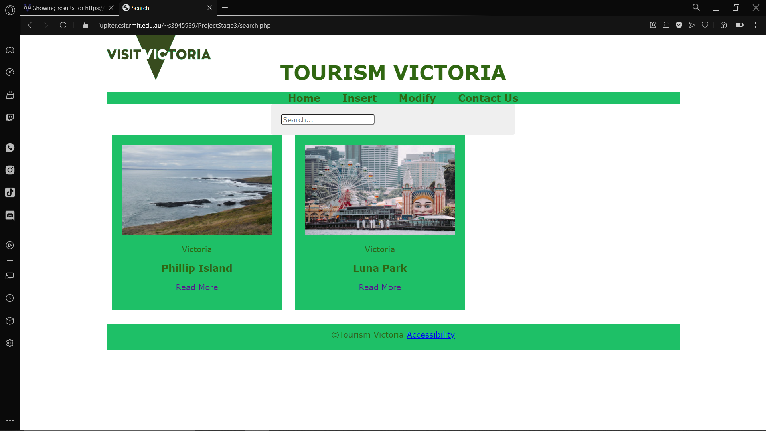

**Search using keywords which are NOT in the database table**

Is a message displayed telling the user that no records were found?

**Enter data into all fields using a test record**

* Is a confirmation message displayed?

**Select Home option on the navigation**

* Is the name and image of the new record displayed?

**Click the details hyperlink**

Is the correct record displayed?

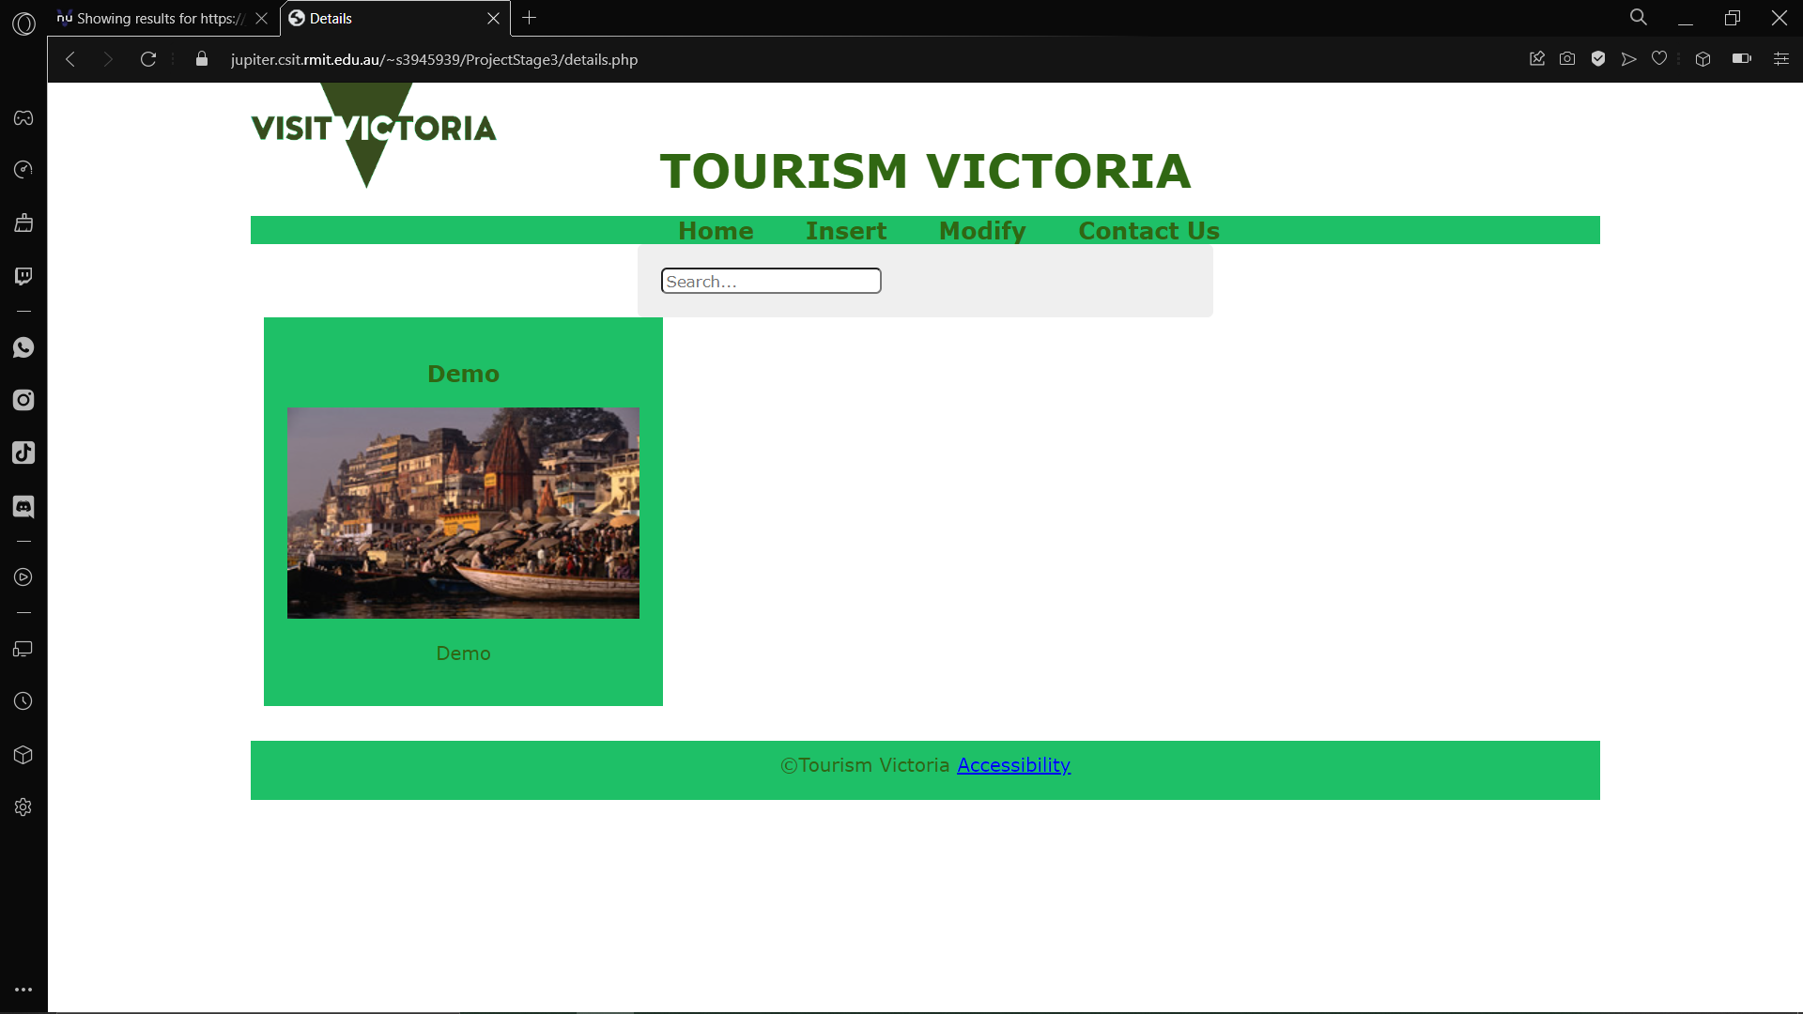

Insert data for a new record BUT leave one text field blank and do not browse for an image

* Is a message displayed telling the user that fields cannot be left blank?

Insert text with both single and double quotes and press submit

The record should be created with no errors.

Select the navigation option to **display all records** and view the new record

The text should contain the quotation marks

Make changes to the text data

* type in something obvious like aaaaa

Click update

* What message displays on the page?
* Is there a navigation on the page?

Select the navigation option to display all records

* Has the record been updated with the new data?

Select modify

Choose a record and click the delete hyperlink

View the confirmation page

* Are the record details clear?
* Is there a clear delete confirmation heading?
* Is there a cancel hyperlink?

Click the **cancel** hyperlink

Are you returned to the previous page?

Select a testing **record** to delete

View the confirmation page

Click the delete hyperlink

* What message is displayed?
* Is there a navigation on the page?

Select the navigation option to display all records

* Has the record been deleted?
* The record should not display

